Pterodactyl Overdrive Industries
ALPACA
Software Design Specification
Version 1.0

Revisions
Version | Primary Author(s) | Description of Version | Date Completed
1.0 | Mel | Initial document | 11/18/2014
1.1 | Steven | Class diagrams | 11/25/2014
1.2 | Mel | Finalize, formatting | 11/25/2014
Contents
1 Introduction 1
1.1 System Overview 1
1.2 Supporting Materials 1
1.3 Definitions and Acronyms 1
2 Design Considerations 2
2.1 Assumptions 2
2.2 Constraints 2
2.3 Goals and Guidelines 2
2.4 System Environment 2
2.5 Development Environment 2
3 Architecture 3
3.1 Overview 3
3.2 Strategies 3
3.2.1 Standards 3
3.2.2 Flexibility 3
3.2.3 Scalability 3
3.2.4 Customizability 3
4 High Level Design 4
4.1 Hierarchy Chart Of Components 4
4.2 Sequence Diagrams And Descriptions 4
5 Low Level Design 5
5.1 Component C1 5
5.1.1 Class D1 Of Component C1 5
5.2 Component C2 5
6 User Interface Design 6
6.1 User Interface Design Overview 6
6.2 User Interface Navigation Hierarchy 6
7 Requirements Traceability Matrix 7
8 Appendices 8

Introduction

System Overview
The Announcement and Liaison Provider for Academic Conference Administrators (ALPACA) is a web-based email assistant system for individuals serving as Publicity Chair for an international academic conference. Upon logging in to the system, the Publicity Chair will interact with a simple interface for creating email announcements pertaining to the upcoming conference. The system will aggregate and maintain a list of contact information (names and email addresses) for potential conference participants and attendees. Management of said list consists of adding and sorting entries, preventing duplicates, and removing unreachable email addresses – automatically upon failure of delivery, or as specified by the user (the Publicity Chair). A user may also choose to export his or her contact list to a file. The system will connect to existing email systems to send the completed announcement in bulk to all members of the recipient list.

Supporting Materials
Links to third-party software employed by this project:
- Microsoft .NET Framework: www.microsoft.com/net
- nHibernate Framework: www.nhforge.org
- Twitter Bootstrap: http://getbootstrap.com/
- Kendo: www.telerik.com/kendo-ui

Definitions and Acronyms
Term | Description
ALPACA | Announcement and Liaison Provider for Academic Conference Administrators
Publicity Chair | An individual tasked with providing information about an upcoming conference to its participants via email. These emails may include calls for submissions, scheduling updates, and general conference details. This the primary user of the system, and this document employs the terms “Publicity Chair” and “user” interchangeably.
MVC | Model-View-Controller, the design pattern upon which ALPACA’s software architecture is based.

Design Considerations

Assumptions
This project assumes that users will have internet access at all times when interacting with the system, and does not propose to offer any offline functionality.
ALPACA will require Window 7 or Windows Server 2008 (or any version of Windows Server thereafter) for hosting. The operating system is required to have the .NET 4.5 Framework installed.
The application will utilize Twitter Bootstrap for scaffolding and styling. The interface should feel responsive and utilize the benefits of Bootstrap to shrink and expand appropriately with the browser, to provide a consistent look and feel. The color scheme will follow the standard Pterodactyl Overdrive Industries color scheme for web applications. Components from the Telerik Kendo user interface libraries will also be incorporated.
ALPACA will utilize a Microsoft SQL Server 2012 database for data storage. The default database size will be set to 1GB. This database will be co-located on the same server that the application is hosted on due to budget constraints. Due to the relatively small user base of ALPACA, this design is not perceived to impact performance or the overall user experience. The web server will establish on-demand connections to the application database via third party ORM framework nHibernate, version 3.3.3.

Constraints
ALPACA will be developed using the Microsoft .NET Framework and the C# programming language, and as such will require Windows 7 or Windows server 2008 at minimum for hosting. The .NET framework will also be required. ALPACA will be a purely web-based application, and all standard, modern browsers will be supported.

ALPACA will send the user’s email announcements via existing email systems, including proprietary email services (Outlook, e.g.) and common webmail providers, using SMTP. The system will support authentication, and will use SSL for security, via the appropriate SMTP server port. Email announcements will be sent in bulk, rather than requiring the user to submit each one. Each announcement will be sent as a blind carbon copy (Bcc) in order to personalize the experience of the recipient. Optionally, the recipient’s name may be included in the body of the announcement. Multithreading will be used to ensure the system does not excessively monopolize CPU resources. The interface for email announcement creation will support Rich Text Format.

Goals and Guidelines
The primary goal of ALPACA is user-friendliness. Users should feel comfortable using ALPACA without any training or instruction. Ease of use and navigation are paramount to ALPACA’s design principles because users need to feel empowered to focus on their own areas of expertise, rather than concerning themselves with the technical aspects of the application. ALPACA should be an intuitive tool that functions within the familiar problem domain of the user, rather than requiring the user to branch out from his or her area of expertise.

Architecture

Overview
ALPACA will employ the Model-View-Controller (MVC) pattern within the .NET Framework for its architecture. The project solution is divided into Main, Database, Web, and Testing projects. Business logic is separated from user interface models by controller classes. Business and interface objects may also interact with the database through NHibernate classes.

Strategies

Standards
- HTTP Standards

HTTP/1.1 (as defined by RFC 2616) will be the communication standard for ALPACA for both requests and responses. The application will require the appropriate GET, PUT, POST, and DELETE requests headers, depending on the transaction (as defined by their appropriate usage in the above RFC document.) The application will not support browsers incapable of utilizing HTTP/1.1.

- SSL Encryption

All actions taken by the user will be encrypted to a minimum of 128-bit encryption, passed over Secure Socket Layer (SSL.) In addition, to ensure user privacy and reduce the threat of data compromise, user passwords will retain encryption from initial login to database storage.

- SMTP Usage

Interaction with the Email system will occur over a secure SMTP channel.

Technical Environment
The application and database server will require the following hardware specifications:
- A clock frequency of 3.0 GhZ on a multi-core processor (2 cores or greater)
- Eight (8) GB of memory
- 10 GB of free disk space
- Dedicated WAN access with a minimum of 24 Mbp/s download and 16 Mbp/s upload.

System Integration
ALPACA is designed to function within all modern browsers. It will provide email functionality via existing email providers – both free webmail services (gmail, e.g.) and proprietary services (Outlook, e.g.), and will use SMTP.

Maintainability
From the client’s perspective, ALPACA should be relatively impervious to business changes. If the client changes their email provider, this should not affect their ability to connect to ALPACA.
On Pterodactyl Overdrive’s end, ALPACA is designed to be both modular and extensible. The use of the MVC design pattern creates a simple framework that can adapt to a changing software environment as needed.

Performance
Sorting of the contact list will take place in O(n log n) time. Multithreading will be used to ensure the system does not excessively monopolize CPU resources. The default database size will be set to 1GB. This database will be co-located on the same server that the application is hosted on due to budget constraints. Due to the relatively small user base of ALPACA, this design is not perceived to impact performance or the overall user experience.
The availability of the system will be strictly dictated by the required maintenance on the server on which the application will be hosted. The maintenance is scheduled to occur at the very most once per week and for one hour per maintenance session. This required maintenance brings the overall availability of the application to 99.4%.

Software Specification
ALPACA will be developed using the .NET Framework 4.5, MVC 5, and the C# programming language, using Microsoft’s Visual Studio 2013 IDE. Source control will be handled using git and Github. ALPACA will utilize a Microsoft SQL Server 2012 database for data storage. The web server will establish on-demand connections to the application database via third party ORM framework nHibernate, version 3.3.3.

Hardware Specification
- Clients
  - Laptop and desktop computers with internet access
  - Mobile devices with internet access and web browsers
- Servers
  - Database server - Microsoft SQL Server 2012
  - 1 GB storage capacity
- Network
  - IIS (Internet Information Services) version 7 or later
  - Dedicated WAN access with a minimum of 24 Mbp/s download and 16 Mbp/s upload.

High Level Design
Since the design of this system was based on MVC 5, it is naturally decomposed into Model, View, and Controller components as specified by that design pattern. The Web project holds user interface and view objects, while the Main project contains the business logic and the controllers that connect the two. The Database project further encapsulates the database files.

Hierarchy Chart Of Components
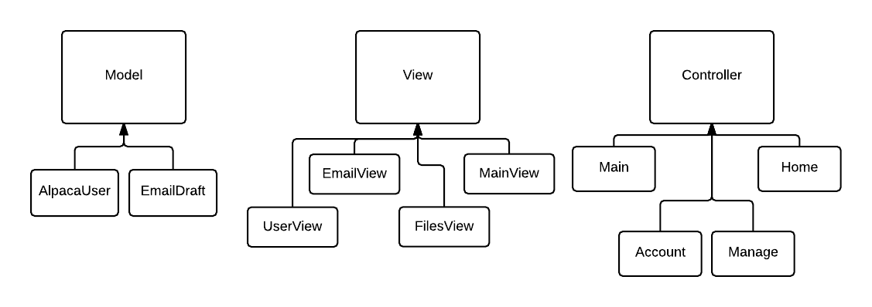
The MVC design pattern offers us a simple way to decompose our project into three components. The Model component represents the entities, the View component represents the boundary objects, and the Controller component represents the control objects. These components and their parts are further discussed in section 5.

Sequence Diagrams And Descriptions
Use case: AddToList
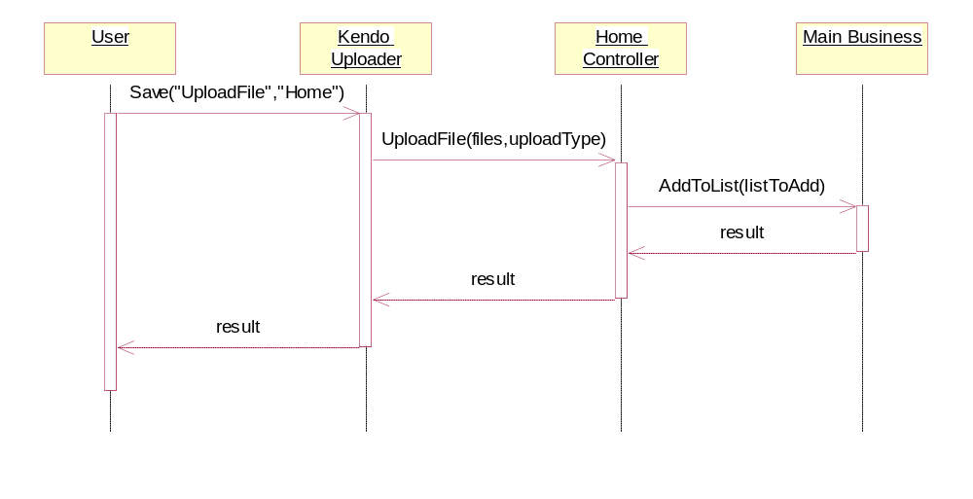
Here, the Kendo Uploader is a class provided by Telerik Kendo. HomeController and MainBusiness are control and entity objects. Each class returns an HTML result which is ultimately rendered onscreen as a success message.

Use case: RemoveFromList
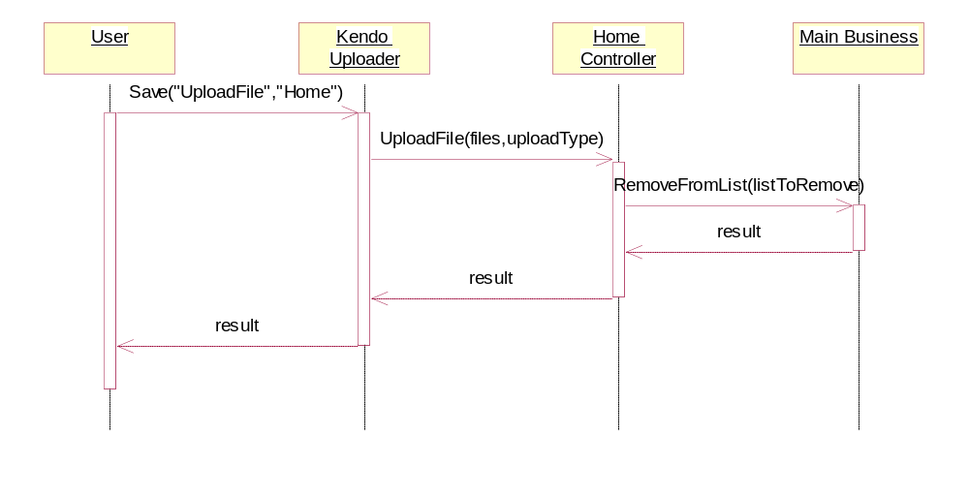This diagram also includes a reference to the Kendo uploader. The uploader is rendered as a widget that the user can interact with to select and confirm files to upload.

Use case: SendEmail
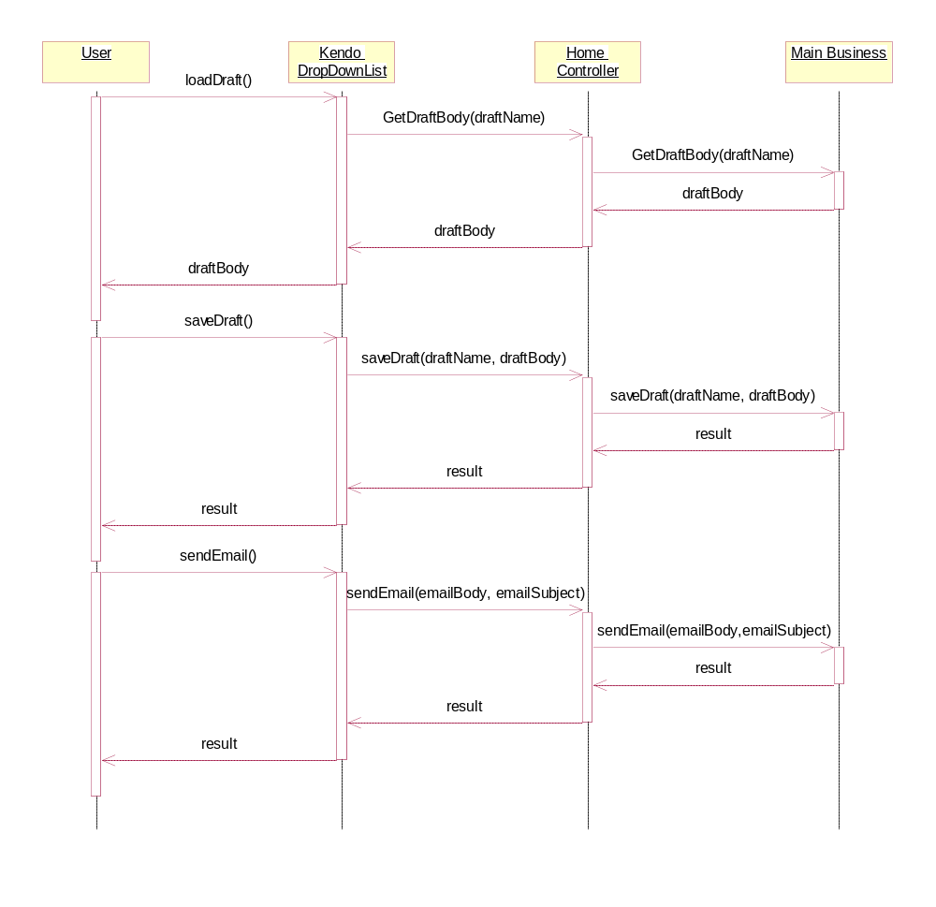
The methods for loading and saving drafts are optional parts of this use case. A user may simply begin composing a new draft and send it without saving. However, in the most complicated case, a user may load a save draft, edit it in the rich text editor, save the edited draft, and then send the email. Each class returns a JSON result which is ultimately rendered on screen as a success message.

Use case: AddUser
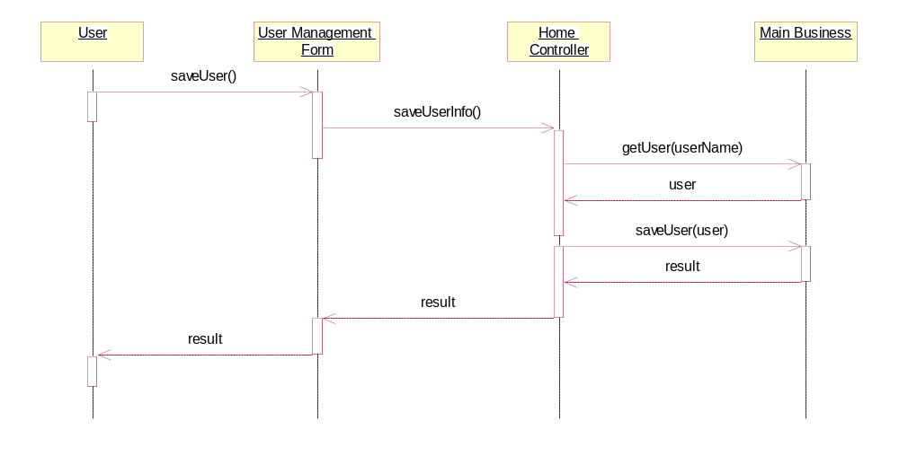
The UserManagementForm is a partial view that appears in the user management tab on the main ALPACA screen. The user can populate the relevant fields and click the submit button to initiate this use case.The HomeController calls MainBusiness to query for the current user, which is passed back as an AlpacaUser object. This user object is then used to save the user information entered by the user.
Use case: EditUser
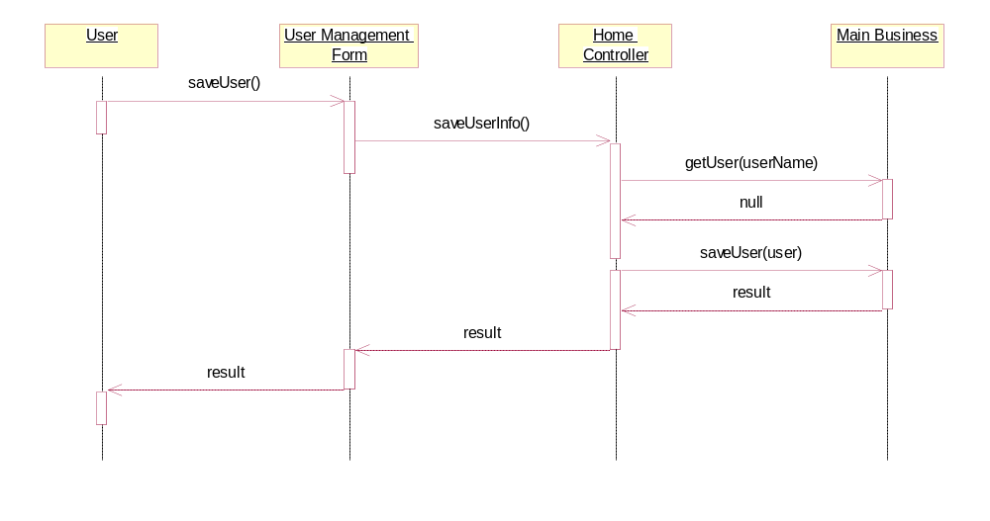
This use case is very similar to the AddUser case, except that when the HomeController queries for the user, it finds that no such user exists. Instead, it creates a new user and inserts the information into the database.

UseCase: DeleteUser
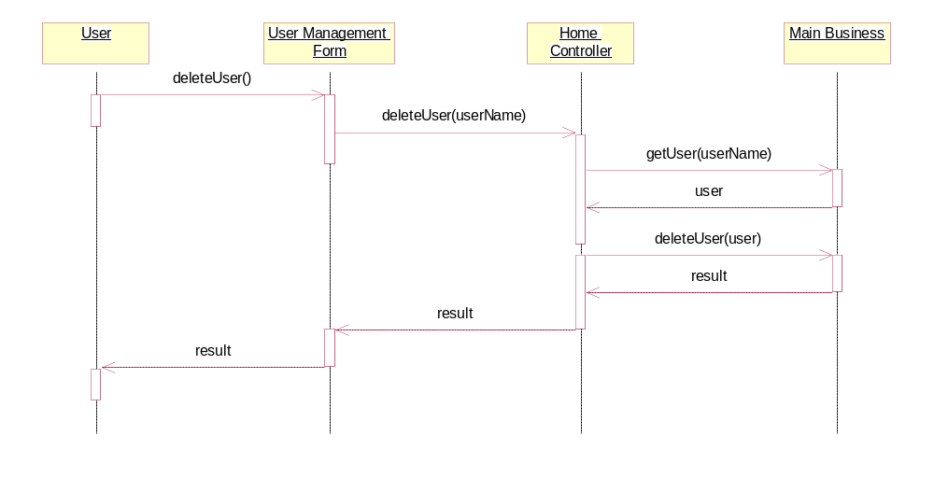
This use case is similar to the other user management cases. Here, after the HomeController queries for the user, it calls the deleteUser method of MainBusiness. Results are returned in the form of JsonResult objects, which are ultimately rendered as a success (or failure) message to the user.

Low Level Design

Model

Class AlpacaUser Of Model
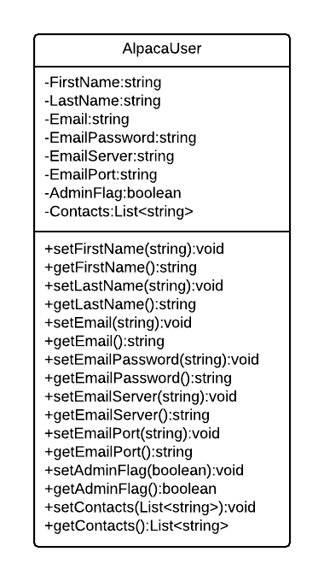
AlpacaUser houses the attributes of the user and provides access methods for the attributes.

Class EmailDraft Of Model
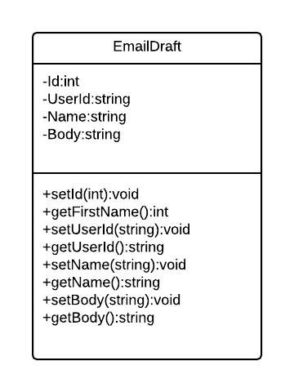
EmailDraft houses the attributes of Email Drafts and provides access methods for the attributes.

View

Class UserView Of View
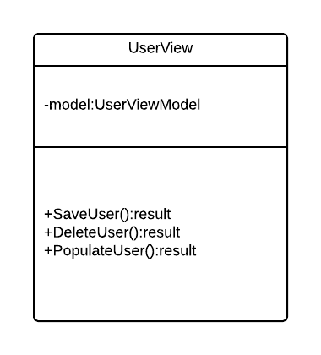
The UserView is responsible for providing a boundary between the system and the user. It is responsible for allowing the user to interface with the user management functions.

Class EmailView Of View
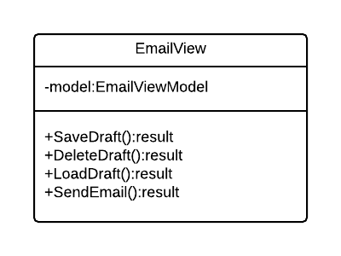
The EmailView is responsible for providing a boundary between the system and the user. It is responsible for allowing the user to interface with the email functions.

Class FilesView Of View
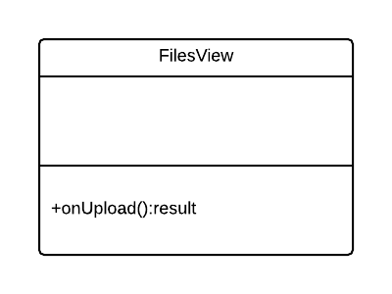
The FilesView is responsible for providing a boundary between the system and the user. It is responsible for allowing the user to interface with the list management functions.

Class MainView Of View
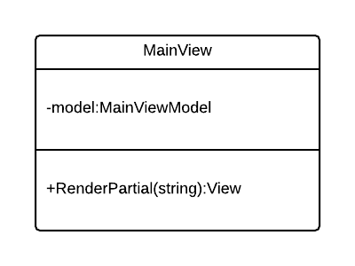
The MainView is responsible appropriately rendering the other Views based on the user’s role in the system.

Controller

Class MainBusiness Of Controller
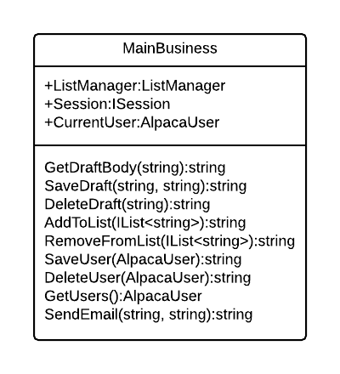
The MainBusiness class is responsible for all of the core application logic. It provides database interfacing for email draft and contact list functionality. It also provides all of the user management functionality and email functionality.

Class AccountController Of Controller
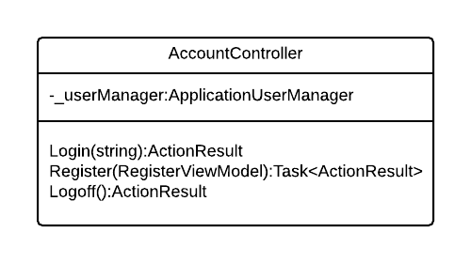
The AccountController class is responsible for handling user registration and managing login and logout functionality.

Class ManageController Of Controller
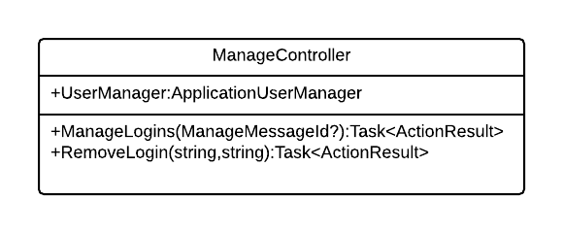
The ManageController class is responsible for managing the user login sessions. It supports the AccountController with login and logout functionality.

Class HomeController Of Controller

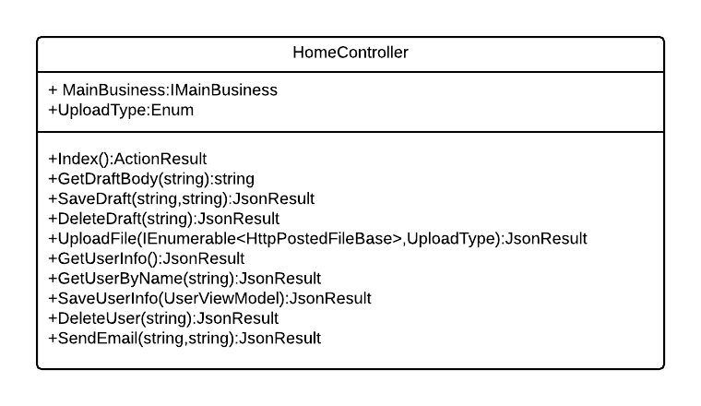
The HomeController is responsible for handling requests passed from the various View boundary objects. It provides a link from the web application and presentation logic to the core application logic.

User Interface Design

User Interface Design Overview
In accordance with our principal design goal, user-friendliness and intuitiveness have guided our interface design decisions. The application will render as a single page, with the main focus on the email body composition field. This field is implemented as a partial view. Below, a tabbed browsing area will display two other partial views, one for list management, primarily in the form of file uploads, and one for user management in the form of data entry fields.

User Interface Navigation Hierarchy
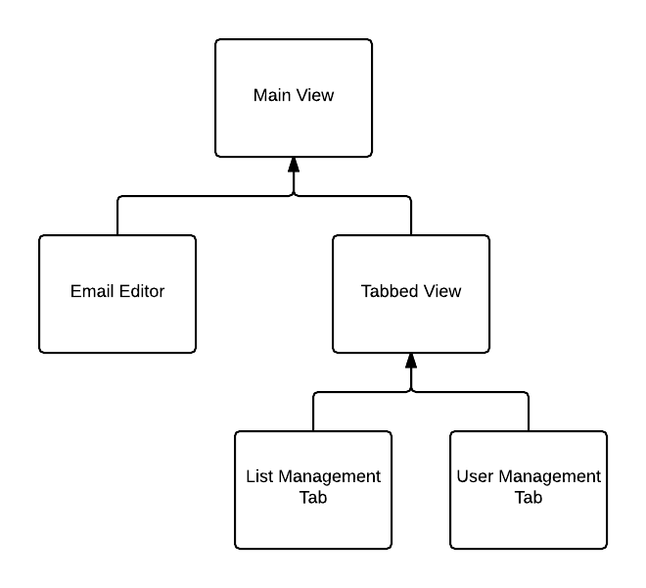

Requirements Traceability Matrix

Section of This Document | Corresponding Sections of ALPACA SRS
1.1 | 1.1
1.2 | 1.3
1.3 | 1.2
2.1 - 2.2 | 2.3 - 2.4
3.2.1 | 3.1.4
3.2.2 | 3.1.2
3.2.3 – 3.2.5 | 2.3
3.2.5 | 3.3.1
3.3 | 3.1.3
3.4 | 3.1.2 – 3.1.3
6.2 | 3.1.1

Appendices
.

